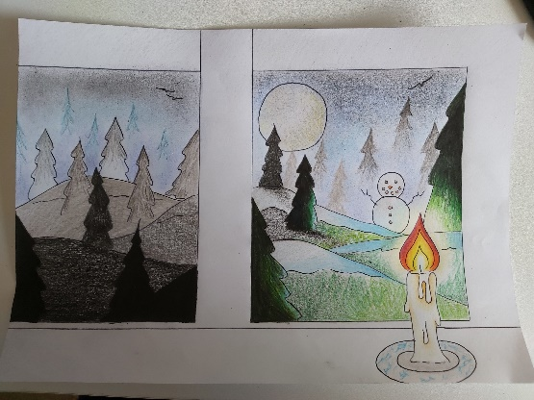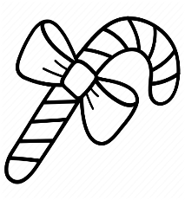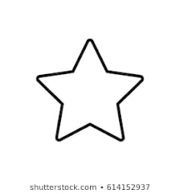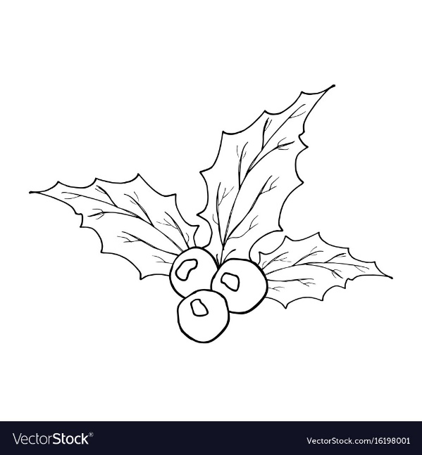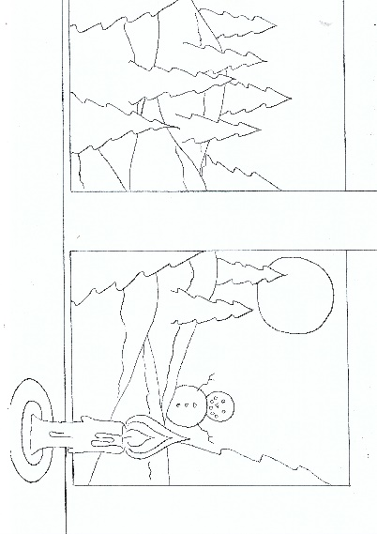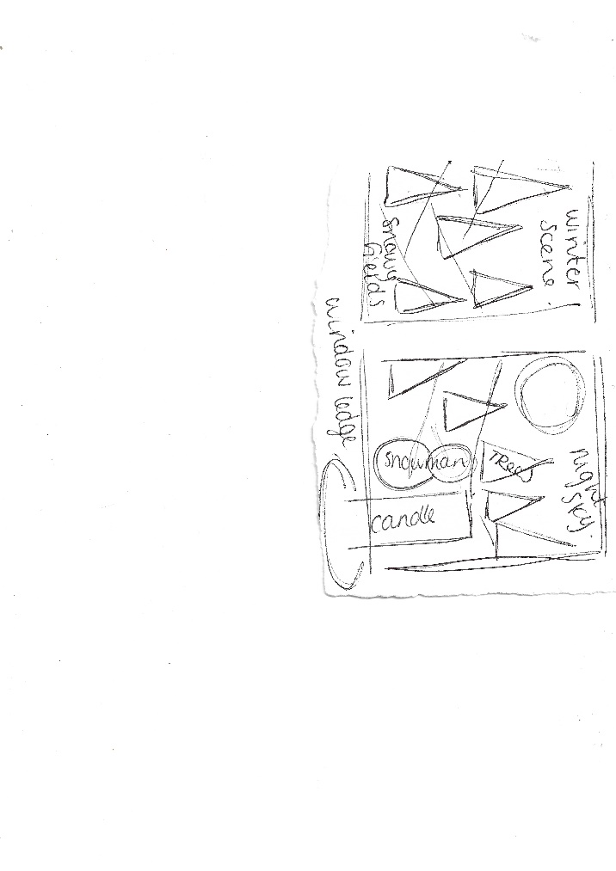

My Finished Artwork: ‘Winter Nights’

My words:

Tree, Candle, Snow, Snowman, Winter

I decided to use colouring pencils you use whatever materials/media that you like.

If you want to you could cut out the images on the title page or trace the images of this page and include them in your design.

Finished drawing

Planning sheet

**2)If your happy to start the drawing and see where it takes you including the word prompt illustrations as you go along – feel free to just start drawing.**

Next, there are 2 routes you can go down depending on how you like to create.

**1)You can either plan your piece in small sketches and have something that looks like this (below).** I just used a scrap piece of paper, outlining shapes to see how I wanted the individual drawings to fit together.Writing words on helps me to remember what each shape symbolises, the planning is quick, so you do not need to spend time on it. You just want to create a scene that your happy with, that fits in with your word prompts.

Starting a new piece is often the part I find hardest; the first few marks on the paper can seem scary if you don’t know where you want to go with the work. This is where planning can help, **write a list of 5 to 6 words from the prompt list** which you would like to turn into illustrations for your artwork.